project proposal briefing

Land Acquisition Fund

The main objective of the IUCN NL Land Acquisition Fund (LAF) is to provide funds for local NGOs and CSOs to acquire threatened nature, create safe reserves and connect wildlife habitats for endangered species. The fund supports land purchase, long term lease of land and other effective area-based conservation measures (OECM). Since its foundation in 2001, LAF has enabled the purchase / lease of over 60.000 hectares. The LAF is supported by a growing number of private donors. This project proposal briefing outlines the practical details and requirements for applications.

Criteria for application

I. Project objective
The general objective of a proposed project must be in line with the main objective of the LAF.

II. Implementing organization

Proposals can be submitted by local NGOs, CSOs with:
- experience and capacity concerning the effective management of a conservation area, and
- experience and capacity in the field of project management, financial management and - control

LAF cannot grant financial assistance to:
- Private individuals
- Commercial (for profit) organizations
- Governmental institutions
- Projects /organizations with a primary focus on sustainable agricultural systems, education- , rescue- or rehabilitation centres

III. Project area
High priority will be given to land acquisition (through purchase or lease) or implementation of OECMs to:
- secure areas hosting species listed as threatened (CR, EN or VU) on the IUCN Red List [www.iucnredlist.org];
- Secure areas with a high biodiversity value, like Key Biodiversity Areas;
- Secure areas that are important in a broad approach for securing the connectivity in a high biodiversity value landscape (corridors, stepping stones) or to secure ecosystem services;
- Secure ecosystems underrepresented in the public protected areas system;
- Secure important populations of threatened plants and trees. Such proposals should preferably target protection of range-restricted tree species, an Alliance for Zero Extinction site or a unique part of the range of a species.

IV. Geographical range
Local conservation NGOs, CSOs working in Africa, Asia, Latin America and the Pacific are eligible for this program and are invited to submit their proposals.

V. Local participation
The project should seek to harmonise with the needs, views, expertise and experience of local stakeholders, including attention to the role of women and marginalized groups. Local participation in conservation and management of the area should be central to the proposal.

VI. Amount & spending of the grant
The maximum financial assistance provided by LAF is Euro 85,000. Co-funding of projects is possible when the impact of the IUCN NL grant is clearly visible and constitutes a substantial part of the overall budget, or when the IUCN NL grant can trigger other donors to contribute. Besides the acquisition of land, the LAF grants can also be used for initial investments to secure the sustainability and conservation impact of the purchase (fencing, signboards, guard’s salary and accommodation, etc). Please note that costs for these investments may take up a maximum of 25% the requested budget.

Application process

A schematic flow chart of the application process can be found in Appendix 1.

I. Pre-proposal
All NGOs must submit a pre-proposal first. A format for pre-proposals can be found in Appendix 2 of this document. Only pre-proposals prepared according to this format, and not exceeding 4 pages, will be considered. The working language of the program is English.

NGOs are advised to read our publication ‘Sustainable Nature Reserves: Guidelines for privately protected areas’ before submitting a pre - proposal (available in English, Spanish and Portuguese).

Important: The availability of good maps is a very important selection criterion. Pre-proposals lacking good maps will be rejected immediately!!

II. Deadline & submission
The deadline for applications is May 1st 2024. Pre-proposals can be submitted in English and Spanish, in a free Word format (.docx) and must be sent to landacquisitionfund@iucn.nl. Questions about the procedure and content of proposals can be sent to the coordinator of the LAF (marc.hoogeslag@iucn.nl).

III. Assessment & selection
All pre-proposals are screened by IUCN NL, supported by an extensive global network of experts. We will invite a limited number of NGOs to submit a full proposal after a positive assessment of their pre-proposal.
The full proposals will be assessed by IUCN NL with assistance of an International Review Committee. A selection of these proposals will be awarded a grant. Final decisions will be made in October 2024.Please note that an invitation to develop a full project proposal does in no way constitute a guarantee that the project will be funded.

Appendix 1

Flow chart of application process

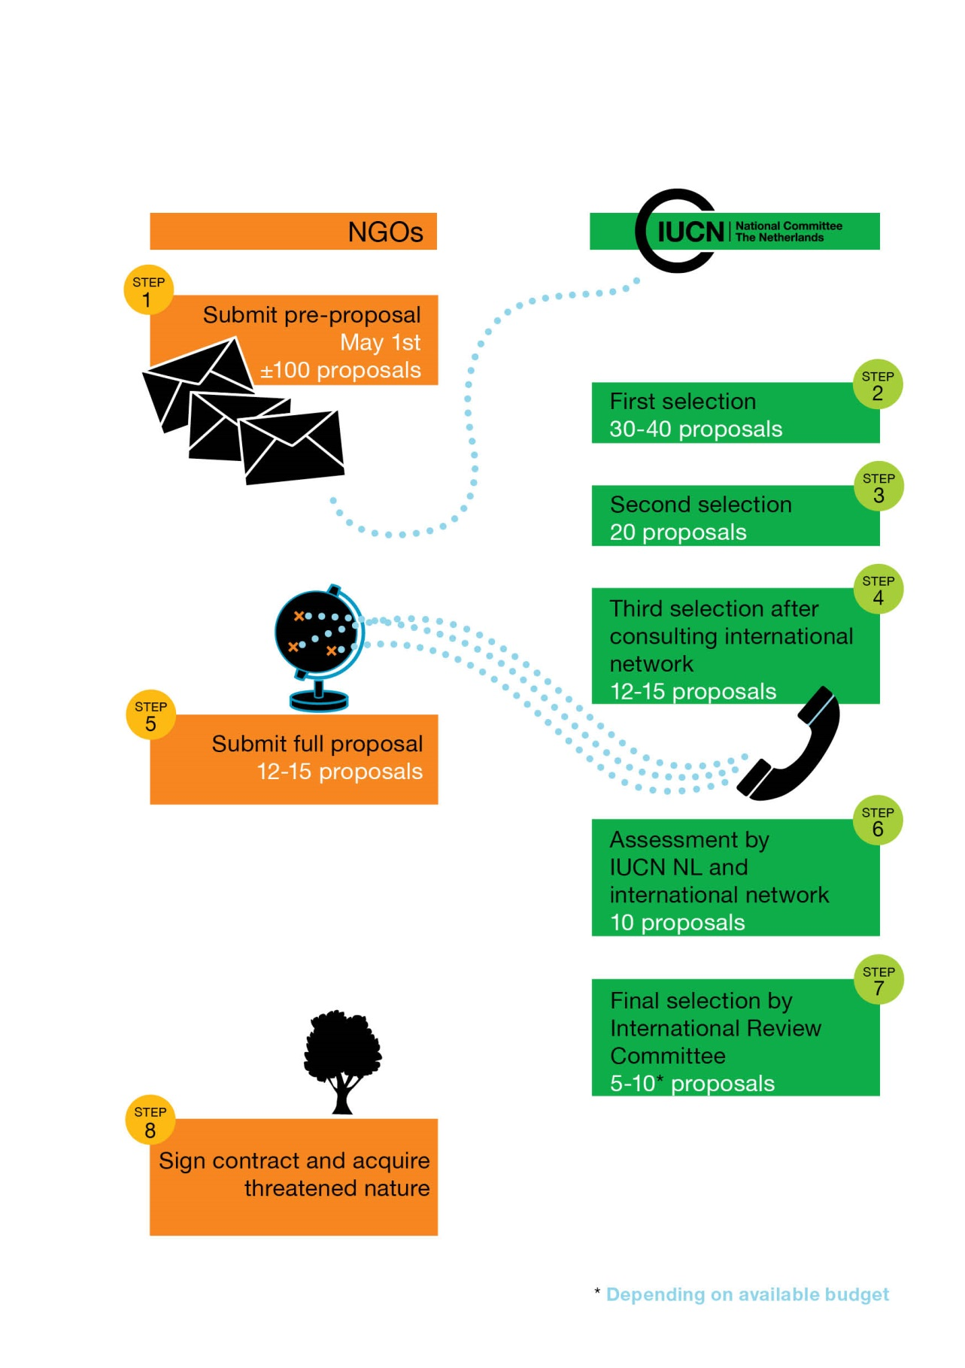

Appendix 2

Format for pre-proposals

KEY INFO
Project title
NGO
Country
 | ☐ Purchase | ☐ Lease  (include lease term (yrs) |  | ☐ Other (OECM)  (please describe)
Number of hectares
Price per ha
Ecosystem
Focal species (incl Red List status)
Total budget requested (EUR)
Co-funding requested to others | ☐ no |  | ☐ yes (please include amount in EUR)

ORGANISATION
Full name of organisation | Legal status
Full name of organisation | ☐ NGO | ☐ CSO
Country of registration:
Address: | Website:
Contact person: | Email:
Qualifications - Explain why your organization is best qualified to implement this land acquisition project (maximum 150 words)

The following information should be provided in maximum 4 pages. Species lists and maps can be provided in annexes.

Project summary – describe the projects’ key features, including objective, location, major threats, species/ecosystem, and approach (maximum 200 words)

Project area
- Map(s) of the project area - map(s) should also show the location of the project area in the wider landscape, and show any other areas that enjoy protection through another legal status like indigenous territories, community lands, sustainable certified forestry concessions
- Description of the project area and wider landscape- Describing land use, vegetation type and –cover, nearby protected areas, show the role of this plot In the wider landscape (why should this be secured?
- GPS coordinates - compatible with Google Earth
- Biodiversity value of project area - For example: presence of endangered (CR/EN/VU) species, endemics, AZE site, KBA
- Main threats and urgency
- Why is the instrument of your choice to secure the land (purchase / lease / OECM) the best solution to secure the land compared to other options?
- Current owner(s) - Is there a willingness to sell / lease / share management responsibility? / is the land title clear and undisputed?
- Will you be implementing restoration activities? – if so, indicate on the map where this will be implemented
- Long term / future management - who will own / manage the land and how will management be funded in the long term?
- Other relevant conservation initiatives in the wider landscape / region

Project partners
- Local stakeholders – describe how local stakeholders are involved in the project
- Other partners to be involved with this proposed project

Budget
- Amount needed for land purchase / lease - in local currency and euros
- Amount needed for other expenses

References (national and international)
- Provide the contact details of persons we can contact about your work. Please note that pre-proposals will be shared with experts in our global network, in order to make a good assessment.

